14 November 2023
Department of Planning & Environment
Locked Bag 5022
Parramatta NSW 2124
Attention: Michael Young - Principal Planner Transport & Water Assessments

RE: DA8137 MAYFIELD CARGO STORAGE FACILITY

Dear Michael
Reference is made to your correspondence dated 12 October 2023 requesting additional information for DA8137 (MOD 2) and your email dated 26 October 2023.
In response, the following information is provided:
- A revised map of the Mayfield Cargo Storage Facility.
As discussed, please find attached an updated plan.

The plan shows a reduced setback of the proposed fence from the uncapped area from 20 metres to predominantly 10 metres. In that area which interfaces with the service road between the M4 Berth and the storage area the setback is largely the existing fence line which is less than 10 metres for a short distance. The provision of a fenced 10 metre buffer in this location will encroach into the service road which links M4 to the cargo storage area. For this reason, a 10 metre buffer is not practical or achievable in this location for operational purposes. It is noted that the location of the fence in proximity to the service road still serves the purpose of isolating the un-remediated area and preventing access.

The originally proposed 20 metre setback of the fence to create a buffer does not have any scientific basis. That setback was notional and only intended to provide a level of comfort by creating a separation distance and did not arise from any recommendation from the site auditor. A fence setback 10 metres from the un-remediated area still serves the purpose of creating an adequate buffer and will prevent use or access to the land.

- Clarify the status of VRA 26025, given that PON advised VRA 26025 was repealed in December 2017.
VRA 26025 was repealed by the EPA and replaced by Ongoing Maintenance Order No. 20142802 which requires the site to be maintained under the Contaminated Site Management Plan (CSMP).
- The request for Modification 2 does not propose any changes to the Condition B9 requirement to remediate the uncapped land in accordance with VRA 26025. As the VRA has been repealed by the EPA is the reference to VRA 26025 still relevant?
VRA 26025 was repealed by the EPA and its reference in the condition is no longer relevant. Ongoing Maintenance Order No. 20142802 references the CSMP as the document to now manage the site.
- How will the remediation of the uncapped land be undertaken if VRA 26025 has been repealed? What are the replacement requirements to ensure the uncapped land will be adequately remediated?

Ongoing Maintenance Order No. 20142802 was issued by the EPA and refers to the CSMP as being the ongoing management plan for the site. Under the CSMP, remediation will be triggered when redevelopment that will involve human occupation occurs, that is when access and use of the area is proposed. The proposed fence to isolate the area is appropriate under the requirements of the CSMP to prevent access and use.

Compliance with Ongoing Maintenance Order No. 20142802 is required under section 28 of the Contaminated Land Management Act 1997. Failure to comply with the order is an offence under that Act.
Please also refer to comments at 6.
- Is Ongoing Maintenance Order No. 20142808 a direct replacement for VRA 26025?

The correct regulatory instrument for the remediation and management of the land in this area of the site is Ongoing Maintenance Order No. 20142802, which repeals VRA 26025 and requires ongoing management of the site in accordance with the CSMP.

- What is the content of Ongoing Maintenance Order No. 20142802 (issued 8 April 2020) and what provisions does it provide for the remediation of the uncapped land?

The following extract is considered the relevant content of Ongoing Maintenance Order No. 20142802 (emphasis added):

3. Commencement of maintenance of remediation
This notice takes effect from the date of this notice and continues in force, unless it is varied or revoked, while the recipient is the owner or occupier of the land.
4. Maintenance requirements
The EPA requires the recipient to maintain remediation action in relation to the land by implementing the CSMP, in so far as it relates to the land.

The principal features of the CSMP are summarised to include, but are not limited to:
a) Areas of the site that identified in section 9.5 of the CSMP (which were not accessible/ could not be remediated) are to be completed during any re-development of these areas;
b) An easement located 5m inside and 10m outside the wall is required to be established and maintained;
c) Drainage on the site is required to be maintained so that there is no water ponding on the site;
d) Long Term Environmental Management Plans (EMPs) are required to be prepared for each development within the site and regulated by the consent authority. While the CSMP will still apply, the EMP’s should be stand-alone and are intended to supersede the CSMP in terms of management of the contamination at each property;
e) A Work Management Plan (WMP) is required for any activity that will disturb or penetrate the cap to outline measures required to protect workers and the environment from contaminants and to identify requirements for reinstatement and validation of the cap;
f) Assessment of the risks to human health posed by the potential ingress of volatile vapours into buildings or confined spaces is required prior to the construction of any buildings on site;
g) Site auditor review of the risk assessment, EMP and WMP is recommended for approval by the consent authority prior to any redevelopments within the site; and,
h) Groundwater is not to be extracted at the site for any purpose.

Additional maintenance requirements of the remediation are as follows:
i) Annual monitoring of groundwater levels must be undertaken by the recipient of this notice in accordance with the report titled Ongoing Monitoring Requirements Former Steelworks Mayfield NSW prepared by JBS&G dated 7 March 2014. The recipient of this notice must report the results of annual monitoring to the EPA within six (6) weeks of the annual monitoring in order to identify any significant change in hydrogeology from that reported in the SAR and associated documentation and to identify any impact that this may have on the containment of contaminants at the site and identification of what rectification has been or is being carried out to address any impact;
j) An annual review of compliance with the CSMP (in so far as it relates to the land) and this notice (an annual review) is to be undertaken by a person who is accredited as a NSW site auditor under the Act (the accredited auditor). The annual review need not review compliance with the CSMP in relation to activities that are regulated by an approval licence under the Protection of the Environment Operations Act 1997. The annual review must be in a form approved by the EPA and must be procured from the accredited auditor by the recipient of this notice within eight (8) weeks of the annual review being undertaken (Note that the annual review does not require the preparation of a site audit report or site audit statement);
k) Any non-compliance identified and reported by the accredited auditor in the annual review is to be addressed by the recipient of this notice within twelve (12) weeks of delivery of the annual review report (or any longer time approved by the EPA) by undertaking appropriate measures to rectify the non-compliance and recording the measures undertaken. To remove any doubt, this clause (k) does not apply to any non-compliance to the extent that they are caused or contributed to by a scheduled activity that is regulated under a POEO license; and,
l) All reports and documentation prepared in relation to this notice are to be retained by the recipient and provided to the landowner and the EPA upon request while the recipient is the occupier of the land.
m) At any time, the recipient may request a change to this notice and must then provide reasonable evidence to the EPA demonstrating the reasons for the request for the change. Any changes approved by the EPA will be documented on the public register.
The CSMP at 15.10.1 - Remediation of Koppers Operational Area addresses the requirements at the subject area.
Application
This Requirement applies to the area identified as Koppers Operational Area, as shown in Insert B in Figure 14.
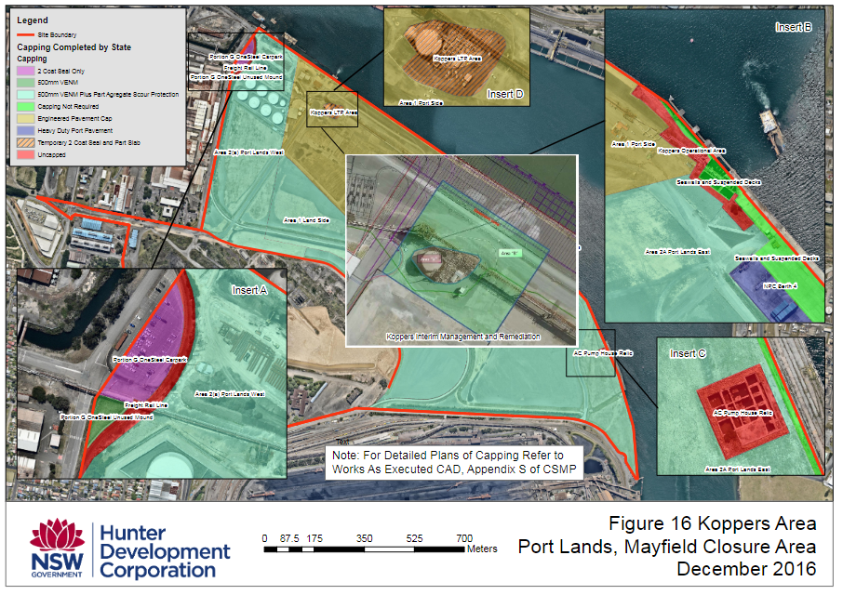
Requirement 15.10.1 – Remediation of Koppers Operational Area
This area is currently used as as a Berth Facility by Koppers. Any change of land use or redevelopment that will involve human occupation will require appropriate remediation measures that meet the VRA, to the satisfaction of the Site Auditor. A Section B Site Audit Statement is to be obtained from the site Auditor to confirm the site has been managed in accordance with the VRA.
The Site Auditor (Fiona Robinson – Ramboll) advises that reference to the VRA is to ensure that the intent of remediation as specified in the VRA is met. The VRA additionally references the Remedial Action Plan (RAP SKM 2004). The VRA and the RAP are both appended to the CSMP. The CSMP, Ongoing Maintenance Order and relevant site audit statement do not include any monitoring requirements for the subject area prior to remediation being completed.

Requirement 15.10.1 of the CSMP triggers remediation of the subject area when redevelopment that involves human occupation - when access and use is proposed. No time frame is nominated. The proposed fence to isolate the un-remediated area is appropriate having regard to the requirements of the CSMP.

- Does the Ongoing Maintenance Order have groundwater monitoring and reporting requirements similar to VRA 26025? Please provide a copy of the Ongoing Maintenance Order.

Yes, the Ongoing Maintenance Order has requirements to undertake annual groundwater monitoring which are incorporated into the CSMP. As noted above, the Ongoing Maintenance Order does not include any monitoring requirements for the subject area prior to remediation being completed.

Ongoing Maintenance Order No. 20142802 is attached.

- Provide an updated condition B9 to reflect the repeal of VRA 26025.
Current condition B9 states:
Prior to the occupation and operation of the additional 6.6 hectares of loading / unloading area approved under DA 8137 MOD 1 the land is to be remediated in accordance with the requirements of Development Application 293-08-00 and Voluntary Remediation Agreement 26025.
Proposed updated condition B9:
Prior to the occupation and operation of the additional 6.6 hectares of loading / unloading area approved under DA 8137 MOD 1, the area marked as the Uncapped Area (Excluded Area) must be isolated by the installation of a security fence as shown in Plan Ref: (Map Description: DA 8137 (MOD 2) Date: 02/11/23). A prominent sign must be placed and maintained on the security fence stating that the Excluded Area is not approved for the storage of cargo and that access to the area is restricted to PON staff or those approved by PON to enter the area.
Condition B10 will also need to be updated for consistency as follows:
Prior to the use of the Excluded Area, the land must be remediated in accordance with any relevant requirements of the Environmental Protection Authority and the Applicant must submit to the Planning Secretary a Site Audit Report and a Section B Site Audit Statement, prepared in accordance with the NSW Contaminated Land Management – Guidelines for NSW Site Auditor Scheme 2018, which demonstrates that the Excluded Area is suitable for its intended use.
The above proposed conditions will mean that any requirements of the EPA will need to be complied with prior to the use and occupation of the Excluded Area, regardless of the instrument that applies at the relevant time.
I trust the submitted information is appropriate. Should you require anything further please contact Philip Carroll – Planning Advisor at Philip.Carroll@portofnewcastle.com.au or 0491 698 443.
Yours sincerely

Philip Carroll
Planning Advisor

